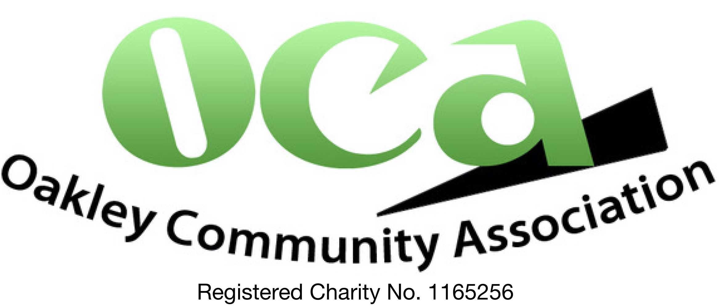
EQUIPMENT HIRING AGREEMENT
NAME

ORGANISATION

CONTACT PHONE NUMBER

ADDRESS

POST CODE
EQUIPMENT REQUESTED

PURPOSE OF HIRING

DATE(S) OF HIRING

The hirer accepts all equipment is lent in full working order. Electrical PAT testing carried out annually. Please read all relevant instructions and list of items included.

The hirer agrees to safely secure the equipment and be liable for any costs incurred as a result of theft, loss or damage

The hirer accepts and understands that they must have full public liability insurance that covers all use of the equipment requested

Donation gratefully received for hire of this equipment £
The hirer accepts all equipment borrowed is to be collected at their own cost from Oakley Community Association and returned immediately following event

Date for equipment to be returned to OCA:
Signed by (please print name)
On behalf of OCA
Signed by the hirer (please print name)
Date:
Office use:
Equipment returned – detail damage/missing items below.
Date:

