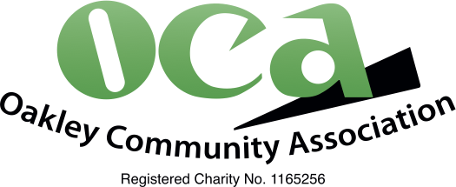

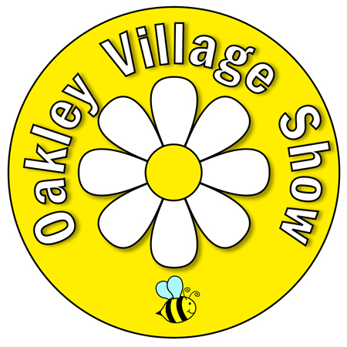

OAKLEY VILLAGE SHOW SCHEDULE 2026

Each exhibitor (ie 1 named person) is restricted to 1 entry per class, for all classes except Art and Photography which are restricted to 2 entries per exhibitor in each class.
All craft items should be clean and not have been entered previously.

CRAFT
A Diamond painting max size 20cm x 20cm

A pair of wooden bookends

A cross-stitch pin cushion

A hat (knitted or crocheted), for a premature baby (hat circumference from 18cm to max 26cm) (may be donated to Southampton neonatal unit)

A soft toy - knitted or crocheted

Something new made from something old

A crocheted scarf

A local play area constructed of Lego

A handmade card - made from a kit - any craft

A handmade card - your original design - any craft, using some pearls

A metal sculpture made out of used screws, nuts, bolts, etc

An item of handmade lace

A completed page from a colouring book for adults

A small Christmas decoration for the tree - any craft

A bookmark not made of lace, themed to a book. Display bookmark with book.

A small quilted item

A free standing kitchen roll holder, made of wood

A piece of jewellery including pearls

PHOTOGRAPHY (Each exhibitor restricted to 2 entries per Class)

Sporting Life

A different angle

Mother Nature

Humanly Speaking

Amazing architecture

Each photograph entered must be separate, unframed and mounted on card. Photographs including mounts must be no larger than 30cm x 30cm.

ART (Each exhibitor restricted to 2 entries per Class)

A themed piece: ’Winter’ in single or mixed media

Water colours and/or pastels

Oils and/or Acrylic

Any other medium such as line drawing, sketches, and other techniques

All signatures must be covered. All paintings and drawings must have a wire or string by which they can be hung. Hooks will be supplied.

CREATIVE WRITING

Entries should be typed with double line spacing and must be original work. Do not write your name on your entry. Closing date 10 July 2026

A poem. Title ’The Voice’

A short story (max 1000 words). Title ’The Voice’

A limerick with a title/theme of your choice

