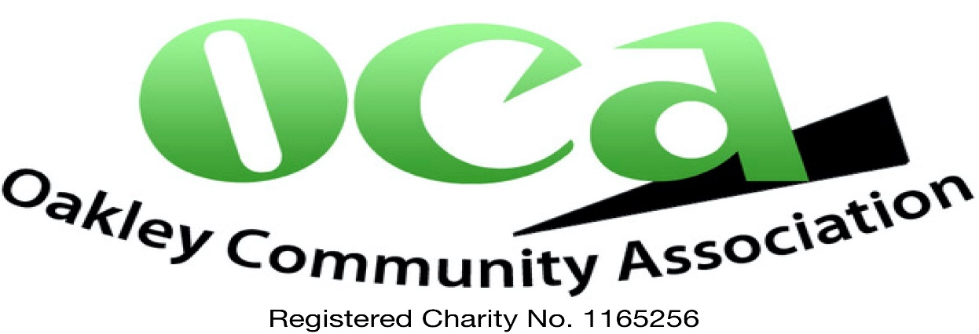

Complaints policy

- Purpose of the policy
Oakley Community Association (OCA) is committed to providing excellent service to its members, participants and community residents (collectively users). However, we recognise there may be occasions where users feel OCA falls short of expected standards. This policy sets out how users can make a complaint and how that complaint will be managed.

- Scope of the policy
This policy applies to complaints that relate to any aspect of a users’ experience.

- Role and responsibilities
- OCA’s Chair has overall responsibility for this policy
- Trustees are responsible for following this policy when they receive a complaint from a user
- the Committee is responsible for reviewing complaints in line with this policy

- How can complaints be submitted?
Users can submit complaints by email to ocaoakley@live.co.uk or by post. Our postal address is 21 Kings Orchard, Oakley, Basingstoke RG23 7AX. We request that complaints are not made by social media.

- Complaints process
- a user submits their complaint using one of the methods set out in section 4. The user should provide:
  - a summary of their complaint – what happened and when?
  - if relevant, supporting evidence
  - a preferred contact method
- the complaint is acknowledged on receipt by the Charity Secretary. The user will be told at that point when they can expect to receive a response
- the complaint is investigated by the Chair within the timescales advised above, being no later than 4 weeks from the complaint.
- the user is told the outcome of the investigation via their preferred contact method.
- the complaint is shared with all trustees at the next Committee meeting to allow learning opportunities to be shared to prevent further complaints.

This Policy will be reviewed at least every four years or earlier should legislation or practice
require. Approved by OCA Trustees 25 January 2024.

