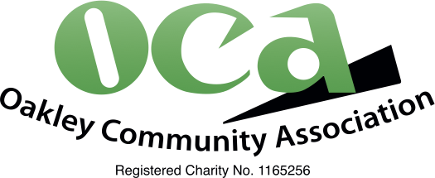

Social Media Policy

- Purpose of this policy
This policy sets out Oakley Community Association’s (OCA) expectations of trustees when using social media.

- Scope of the policy
This policy applies to all trustees.

- Roles and responsibilities
The Chair has overall responsibility for this policy
Trustees are responsible for applying this policy consistently.
The committee is responsible for reviewing this policy every four years or where there have been significant changes

- Definition of social media
Social media is defined as websites or applications the allow the sharing of ideas, thoughts and information through virtual networks and communities. For example Facebook, including Facebook Messenger, Instagram, Twitter, TikTok, YouTube, WhatsApp, Linked In. This list is not exhaustive. In practice it is agreed that most used in the Oakley Community is currently Facebook/Calling Oakley.

- Use of social media
All trustees are permitted to represent OCA on social media, although in practice the majority of social media is managed by Tiffany Wise. When representing OCA on social media you must follow this policy.

- Responsible use of social media
When using social media you must:
- Act professionally at all times
- Signpost users complaining about OCA to our complaints policy
- Use the OCA public email address of hello@ocaoakley.org.uk
- Ensure all trustees receive copies of complaints and responses
- Not harass, bully, victimise or discriminate against any person
- Not breach any legislation. For example, the Equality Act 2010 and the Data Protection Act 2018
- Not damage the charity’s reputation

The policy will be reviewed at least every four years or earlier should legislation or practice require.

Approved by trustees on 26 February 2026

